LAB ASSINMENT-3.4
AI ASSISTED CODING
HT.NO:2303A51685
Batch:13
Task-1: Zero-shot Prompt – Fibonacci Series Generator
Prompt
#Generate python code for printing fibonacci series of first N terms.

Code:
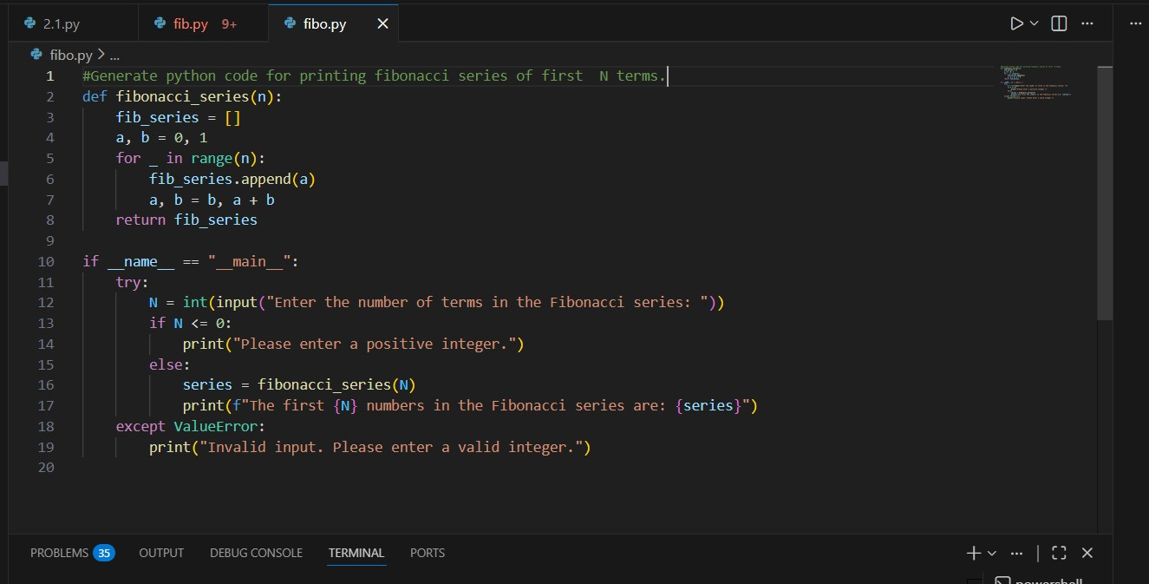
Output:
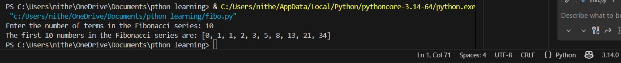
Justification:
Copilot correctly interpreted the term “Fibonacci numbers” without any examples.
It generated an efficient iterative solution using variable swapping.
This demonstrates Copilot’s ability to rely on pretrained knowledge in a zero-shot prompting scenario.

Task-2: One-shot Prompt – List Reversal Function Prompt:
#Generate a python programme to reverse a List [9,8,7,6,5,4,3,2,1 Code:
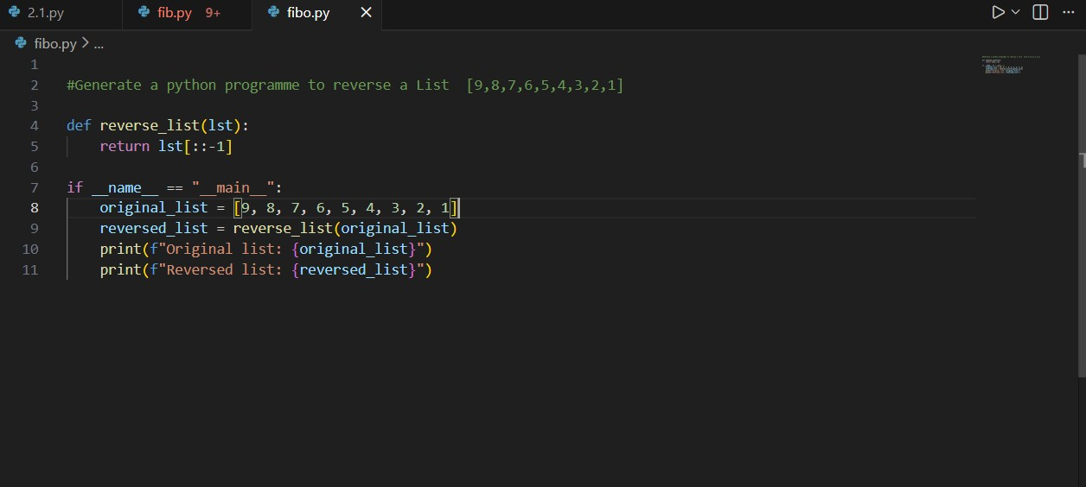
Output:
Justification:
The single example clearly defined the expected input–output behavior.
Copilot accurately inferred the requirement to reverse the list order.
Providing one example improved precision compared to zero-shot prompting.

Task-3: Few-shot Prompt – String Pattern Matching

Prompt:
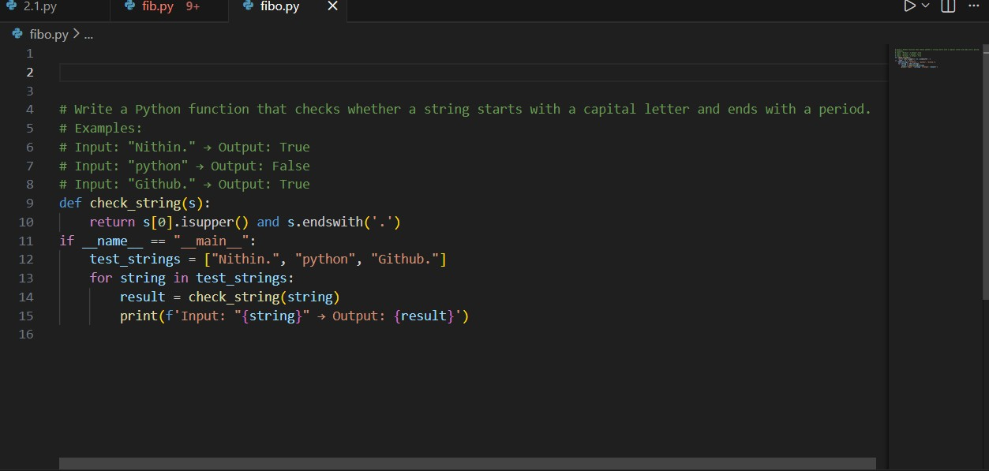
Output:
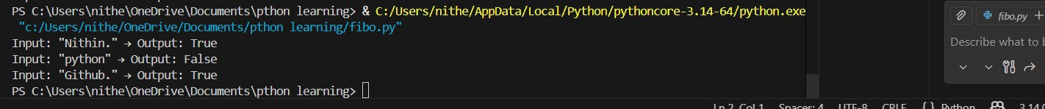
Justification:
Multiple examples clearly defined both valid and invalid string patterns.
Copilot inferred the exact conditions using capitalization and ending character.
Few-shot prompting improved accuracy by reducing ambiguity compared to zero- or one-shot prompts

Task-4: Zero-shot vs Few-shot – Email Validator

Prompt:
Zero-shot:
Code:
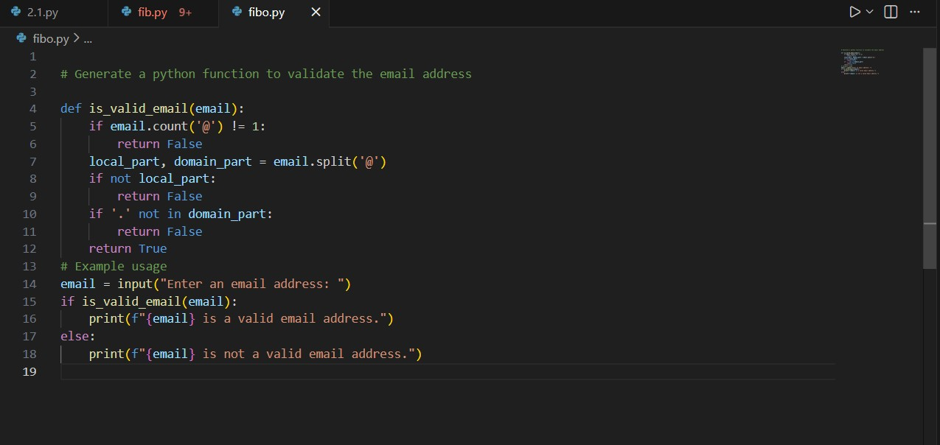
Output:
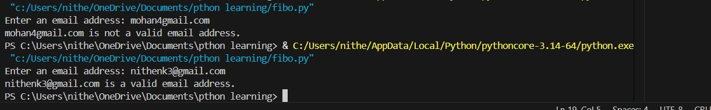
Few-shot:
Code:
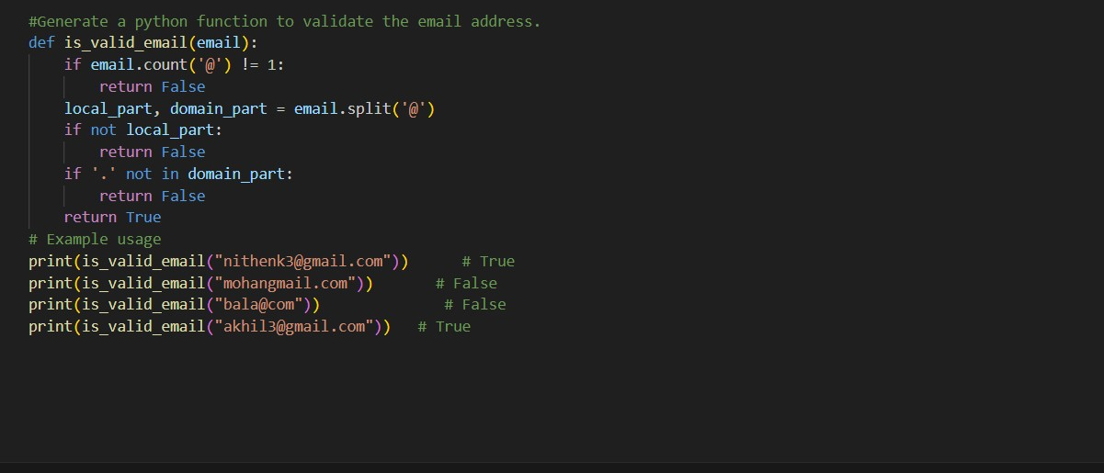
Output:
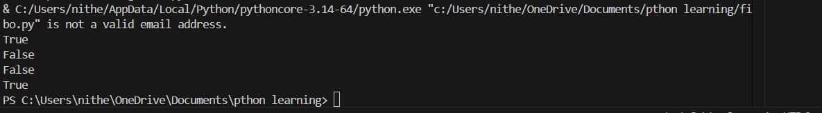
Justification:
- The zero-shot prompt resulted in a basic validation that only checks for symbols.
- Few-shot examples clarified valid and invalid email structures explicitly.
- Providing examples improved Copilot’s reliability and produced more accurate validation logic.
Task-5: Prompt Tuning – Summing Digits of a Number

Prompt:
Style-1:Generic task Prompt
#generate a python function that returns the sum of digits of a number.

Code:
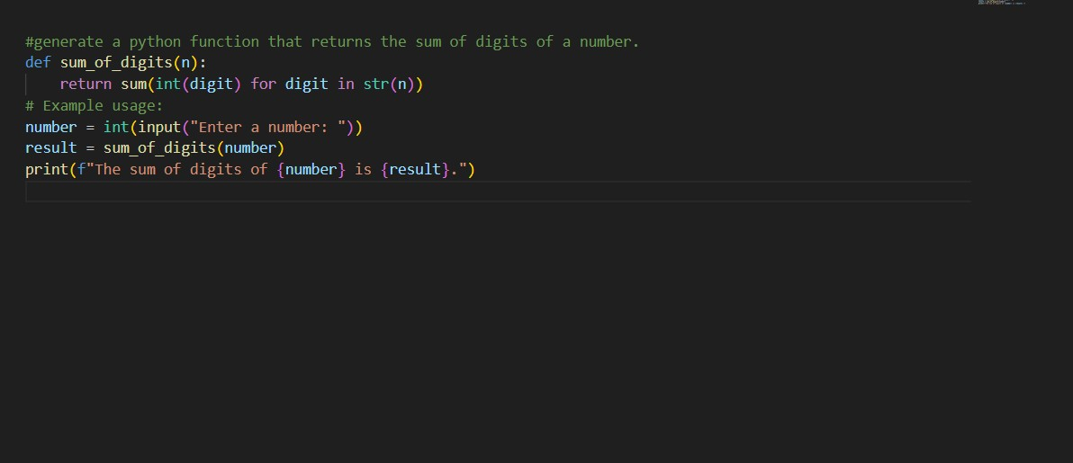
Output:
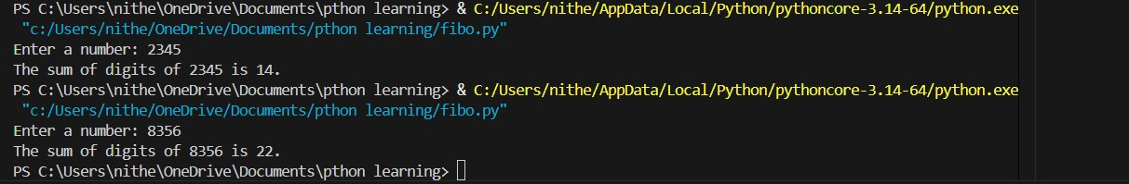
Style-2:
Prompt:
generate a python function that returns the sum of digits of a given number.
Code:
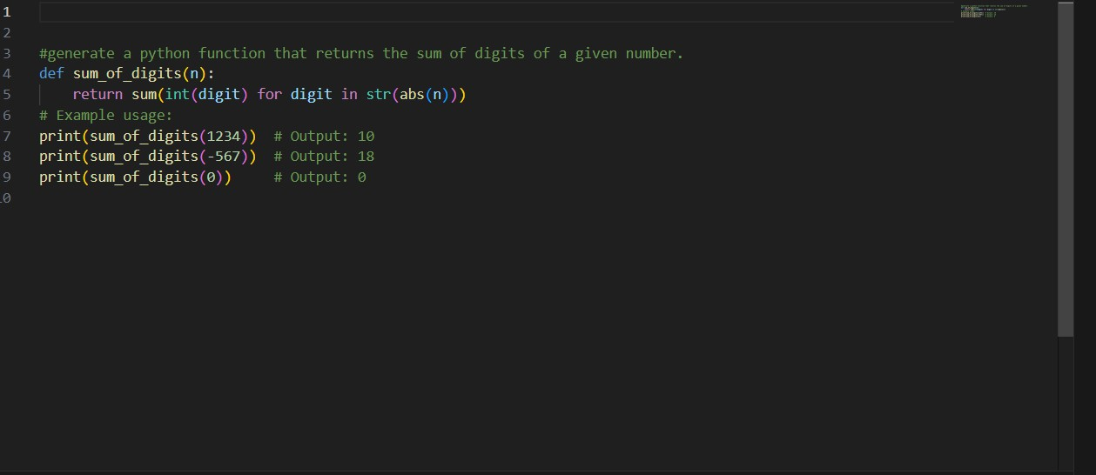
Output:
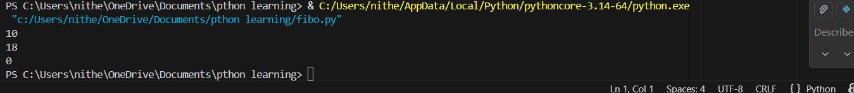
Justification:

- The generic prompt produced a correct but more verbose loop-based solution.
- Adding an input/output example guided the model toward a cleaner, more concise implementation.
- Prompt tuning with examples improves readability and optimization by clarifying expected behaviour.

